**Impacts of Big Data on Business Intelligence**

Name

Department, Institution Affiliation

Course Code; Course Name

Instructor's Name

Date

**Impacts of Big Data on Business Intelligence**

**Abstract**

Historically, organizations have relied on decision support tools to get reliable data needed for effective decision-making in the various cross-functional sectors. Source of big data includes point of sales applications, intelligent systems, smart intelligent systems, and autonomous applications used in the previous past to generate massive data for decision support. Over time, developments have been made that focus on making decisions faster and much more manageable as top management draws attention to the need to relay information instantly. According to (Furht & Villanustre, 2016) these developments have focused on designing new information systems that leverage specific organization performance and deliverables. While this is not true, it's crucial to understand that big data is at the centre of all these. This data is fast moving, voluminous, and contains a given amount of veracity, i.e., has truthfulness as an element. To examine this further, we consider the situations below:

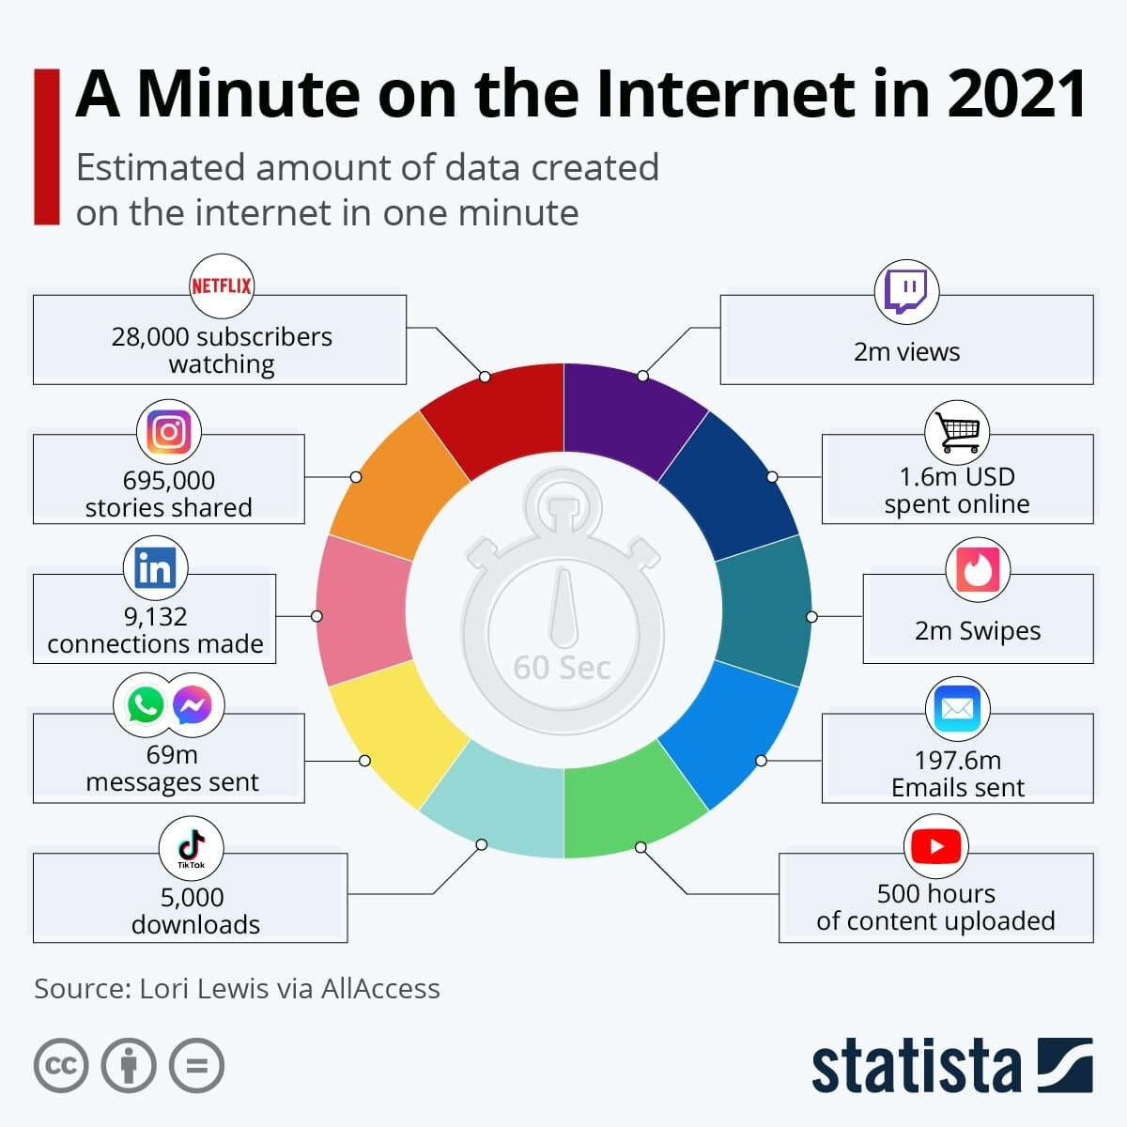

According to statistica.com, in 1 minute, a lot seems to happen; millions and millions of data get generated. This might be defined as big data as we live in a situation and time when too much information is being produced. Do the following questions continue to cross our minds?

* What kind of data is this?
* Where does this data come from?
* How big is this data?
* How do we handle it?

Big data sources include social media applications where millions of posts, comments, and page views are created every hour. Several blogs are generated continuously with large amounts of posts and page views. This sounds interesting for the sales and marketing departments. Such great insights and analytics can be leveraged by the organisation owning this data to be turned into a meaningful and profitable funnel (Hurwitz et. al., 2013). However, this has to be done in an averment that obeys and adheres to different entity data protection laws. After harnessing big data's full power and potential, one of the tools that can be put in place is the business intelligence tool.

Corporations and engineers design BI systems to have quick insights at the click of a button. Different cross-functional departments have to be incorporated together on a single interface. The data pipeline draws the data, and the data moves into the BI system. As docuemnetd by (Sharda et. al., 2014) some algorithms and formulae automatically work on this data and present the data to the user. Also, during the data manipulation state in the BI application, models can be made to forecast and predict the final outputs in the dataset. Such models include logistic regressions, linear regression models, KNN, Random forests, and the ARIMA models. So, where does this leave the big data and BI? Big data can be used to power up BI systems in a massive way and die to generate continuous and voluminous data for the BI systems. With a solid and large BI application, the data can be modelled to help predict outputs and models users can interactively make sense of.

References

Furht, B., & Villanustre, F. (2016). Introduction to big data. In *Big data technologies and applications* (pp. 3-11). Springer, Cham.

Hurwitz, J. S., Nugent, A., Halper, F., & Kaufman, M. (2013). Big data for dummies. John Wiley & Sons.

Sharda, R., Delen, D., Turban, E., Aronson, J., & Liang, T. (2014). Business intelligence and analytics. *System for Decesion Support*.